**Computer Organization and Assembly Language**

|  |  |
| --- | --- |
| **Lab 09** | |
| **Topic** | 1. MUL, IMUL, DIV and IDIV instructions |

**PART 2**

**Problem #1**

**Write an assembly language program to find the area of the TRIANGLE?**

**Height=34**

**BASE=26**

**Note: ignore decimal results.**

**Problem #2**

**Write an assembly language program to convert the temperature units.**

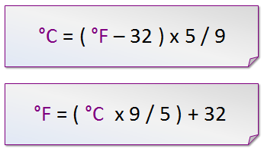

**a)**

**b)**

*For example:* 35℃⬄95℉

**Note: ignore decimal results.**